Lab Title
Science 3315 – Full Course Title

Team X
Team member names

Science Program
Department of Science
Earlham College
Richmond, IN 47374

Date

___________________________
Name with signature (only need to include those who wrote the report here)

___________________________
Earl Ham

___________________________
Marie Claire

General Report Writing Info:
The report should be written in third person and past tense. This is a technical document and should be written as such. Page numbers should be included and should begin after the title page.

Abstract
This section should be between 100-250 words, and should state the lab objective (what you did), your most important quantitative results, and what the results mean. Your goal here is to get the reader to want to read the rest of the report so help them understand the importance of the findings and be specific in your writing. Write this section last.

Introduction
Use the first paragraph to give a short overview of the main lab topic and its relevance to the specific field of science (bigger picture). Think of this as background information for the lab which should include your literature review. Literature can include textbooks and reference books, as well as journal articles that are related to the topic of the lab. Utilize graphics to help illustrate information when applicable. All equations that will be used in calculations for the results should be included in the introduction and their relevance should be discussed. Be sure to center the equation in the text and define the terms. The specific gravity (γ_{s} ) was determined using equation 1
$γ_{s}=\frac{ρ_{s}}{ρ_{w}}$ (1)
Where ρ_{s} is density of the slip, and ρ_{w} is the density of water.
The last paragraph should include the objective of the lab. Consider your results from the lab experiments, what were you trying to determine? This should help you identify the objective of the lab.

Procedure
This section should be written in past tense, describing the experimental procedure in paragraph form. The procedure should also include relevant standards used and an indication of specific modifications made if any. This section should include specifics (exact mass, equipment settings etc.) so that the reader could repeat exactly what was performed in lab. Include the equipment make and model and the material source and purity when applicable.
Example: A mixture of 143.4 g of deionized water, 1.59 g of Darvan 7, and 40 g Al₂O₃ (Almatis, A3500), measured on a Sartorius Basic Balance, were added to a Nalgene bottle along with 40 ZrO₂ ½” milling media. The mixture was then ball milled (U.S. Stoneware Ball Mill) for 24 hours to disperse the Al₂O₃.
Relevant equipment settings should also be included within the procedure section.

Results and Discussion
Tables and Figures are used to present data, allowing for comparison of trends, relationships, correlations, etc. The tables and figures should support your written analysis, meaning the information within the table or figure must be discussed within the text. The table or figure should be introduced within the text body prior to its appearance in the document.
Tables and figure should be included when you need to highlight/emphasize a point. They should help summarize data and improve clarity of your argument. Within your text body you should pull relevant information/highlight key aspects of the table or figure. Typically, tables and figures focus on essential information so raw data is not included (include raw data in the appendix for all courses) rather averages and standard deviations are used. Figures should be numbered sequentially. Tables should also be numbered sequentially using Roman Numerals independent of the figures. Do not include Information in the Table and Figure captions that is not included in the text body. Take time to interpret your results, relate what you are seeing, trends etc, to what you know.
Example: Four point bend testing, summarized in Figure 1, showed that the strength of ZrB₂-SiC ceramics with 5 wt% carbon increased as the volume fraction of SiC increased. The increase in strength is attributed to…
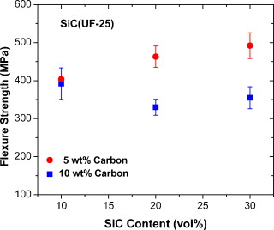
Figure 1. Comparison of the flexure strength of ZrB2–SiC ceramics with carbon additions of 5 and 10 wt% as a function of SiC content.¹
Figure 2 is included here for your reference as an example of another well formatted graph.
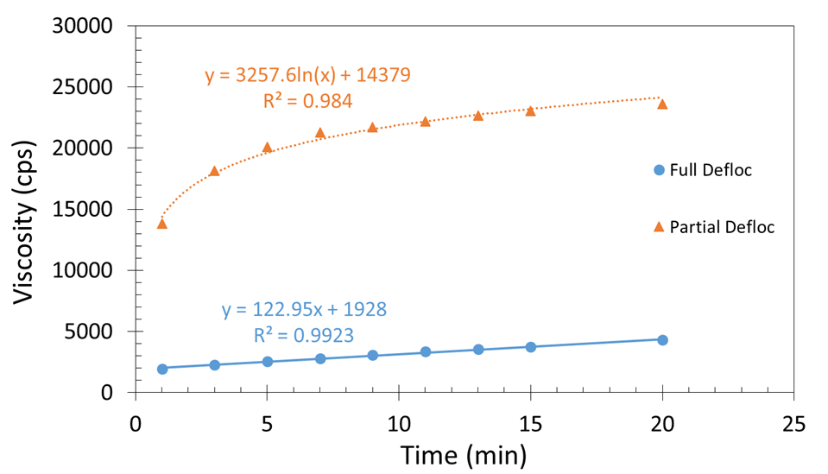
Figure 2. Comparison of the effect of time on viscosity for a fully deflocculated slip compared to partially deflocculated slip indicating early gelling behavior.
Table I summarizes the hardness and modulus results as a function of SiC content. The hardness increased slightly, from 23 ± 1 GPa to 24 ± 1 GPa, with the addition of SiC at all addition levels tested. Additionally, the effect of SiC addition on Modulus does not have an obvious trend.
Table I: Physical properties measured for ZrB₂-SiC as a function of SiC content
Composition  (Vol.% SiC) | Hardness  (GPa) | Modulus  (GPa)
0 | 23 ± 1 | 489
10 | 24 ± 1 | 450
20 | 24 ± 3 | 466
30 | 24 ± 1 | 484

Conclusions
Remind the reader of your objective and confirm if it was met within the lab. Indicate the most important quantitative results and draw conclusions. What do your results mean? The conclusions section might be slightly longer than the abstract, but try to be concise.
Finally, make recommendations for future work or ways to improve the work done.

References
1. S. C. Zhang, G. E. Hilmas, and W. G. Fahrenholtz, "Mechanical properties of sintered ZrB2–SiC ceramics," Journal of the European Ceramic Society, 31[5] 893-901 (2011).

Appendix
For the purposes of our labs you should include raw data tables here, and additional information that is requested that does not belong in the text such as batch calculations or answers to additional questions outside of the scope of the written report.

