Earlham College Health and Wellness Services Transport Protocol

Student referred by professional staff member to Counseling or Health Services.

If student is brought to the attention of Health Services due to expressions of self-harm or concerns related to self-harm, we will direct the student to Counseling Services for a Suicide Risk Assessment. A member of the Counseling Services team, or nurses within Health Services if necessary, may complete the Self-Injury Assessment and Self-Harm Protocol following the completion of the Suicide Risk Assessment as deemed appropriate.

Consultation with the Self-Harm Assessment Team will follow to provide guidance on next steps.

Using the SADPERSONS scale, if risk is low (scoring 0-4), student will complete a safety plan with counselor and ensure safety until follow up session occurs (24-48 hours if occurring on weekend or holiday)

Using the SADPERSONS scale, if risk is high (scoring 5-10), student will be voluntarily or non-voluntarily taken to local hospital: Reid Health.

Health Services: Public Safety will be called by Counseling or Health Services prior to 911. A Public Safety officer will be asked to come to Counseling and/or Health Services to assist with the transport.

The student, counselor and/or nurse enter exam room in Health Services, vitals taken and injuries examined and documented (if injuries present) by the nurse.

Release of information (ROI) is signed before transport and student is encouraged to sign Reid Hospital (or other intended facility) ROI upon admittance to Reid Health and/or additional mental health facility or hospital.

Associate Dean of Student Life for Health and Wellness, Counseling or Health Services will contact the Vice President of Student Life or the Associate Vice President for Student Life in the event the Vice President cannot be reached.

Plan A - Upon return to campus a medical leave of absence (MLOA) is considered and may be issued by the Vice President of Student Life. A ROI and discharge papers including the continued care plan from the attending care provider needs to be faxed to the Associate Dean of Student Life for Health and Wellness before the student is accepted to return back to campus. Outreach is provided to roommate(s) and counseling is offered upon need. A profession al staff member provides supportive outreach to roommate as a form of check in and referral as needed.

Plan B- for if student is unable to return to academic work and/or socialization with peers; campus residence hall/house/apartment key turned into Area Director On-Call, Student ID de-activated by Public Safety until student has been approved to return. Associate Dean of Student Life for Health and Wellness, Counseling or Health Services will contact the Dean/Director on Duty and the Area Director on Duty to complete this request.

Parents are notified regardless of age.
- 2019 Indiana State law: Effective March 2019, Ind. Code 16.39.2.1—16.39.2.12, Protected health and mental health may be shared without patient consent for the purpose of treatment
Abiding by the federal and Indiana state laws along with professional ethical requirements of privacy and confidentiality, family notification may exist under specific circumstances:
- Student has engaged in self-inflicted life-threatening behavior.
- Student is a danger to self or others and is unresponsive to professional medical or mental health guidance.
- Student has completed self- injury and needs immediate off-campus medical attention.

Documentation of session and transport completed by counselor before counselor and Health Services staff member(s) leave for the day or within one business day. Incident report sent to Counseling Services by Dean/Director on Duty, Public Safety Officer, and Area Director on-call.

Consult

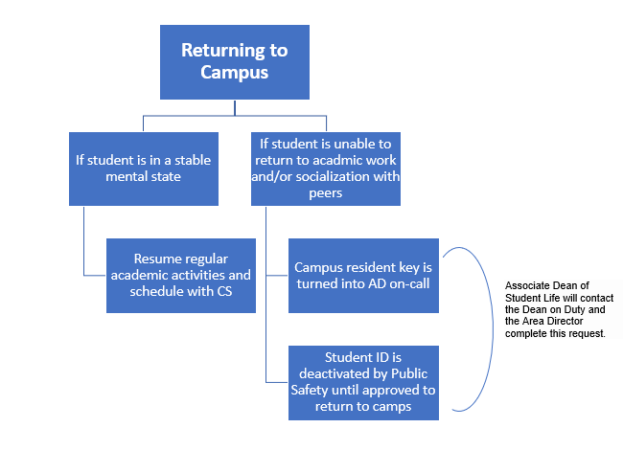
SAD PERSONS scale
S – Sex: 1 if identified male; 0 if identified female; (more females attempt, more males succeed)
A – Age: 1 if < 20 or > 44
D – Depression: 1 if depression is present
P – Previous attempt: 1 if present
E –Ethanol abuse: 1 if present
R – Rational thinking loss: 1 if present
S – Social Supports Lacking: 1 if present
O – Organized Plan: 1 if plan is made and lethal
N – No Spouse: 1 if divorced, widowed, separated, or single
S – Sickness: 1 if chronic, debilitating, and severe
Guidelines for action with the SAD PERSONS scale
Total points | Proposed clinical action
0-3 | Send home with follow-up
3 to 4 | Close follow-up; consider hospitalization
5 to 6 | Strongly consider hospitalization, depending on confidence in the follow-up arrangement
7 to 10 | Hospitalize or commit

